Chapter 7, Solution 69.

Let 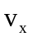 be the capacitor voltage.
For t < 0, 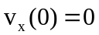

For t > 0, the 20 k and 100 k resistors are in series and together, they are in parallel with the capacitor since no current enters the op amp terminals. As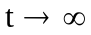, the capacitor acts like an open circuit so that
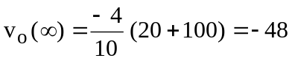
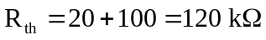,
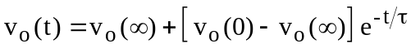
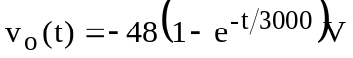= 48(e^{–t/3000}–1)u(t)V

